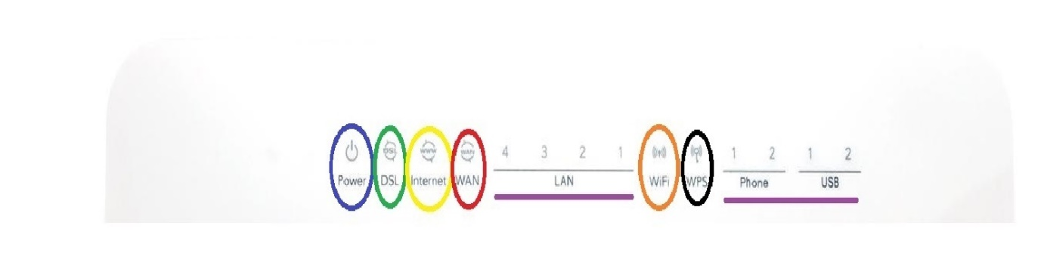

* **Power** – This light indicates that the modem is receiving power. If it’s lit solid green, then the modem has booted successfully and will try to connect to the Internet. A red light will indicate that the modem is faulty or in need of an update, you should seek our help in these cases for confirmation. No light at all indicates that the modem is not receiving power. Check your power button on the side and the power socket or board you’re connected to. You might need to test an alternate power socket if the modem won’t power on.
* **DSL** – This light indicates the modem’s connection to a DSL line, which is only applicable if your connection is Fibre to the Node (FTTN). A tell-tale sign of FTTN is that your modem will plug straight in to a phone socket on the wall. If DSL is solid green, you’re connected to the network and your modem will now try and log you in to the Internet. If DSL is off or flashing green, it indicates that the modem cannot establish a connection to the network. Make sure that your modem is connected to the phone socket by itself, with no filters, splitters or alternate hardware sharing the same socket. You should also test an alternate phone cable and make sure that you’re connected to the DSL socket on the back of the modem, which is grey in colour.
* **Internet** – This light indicates the modem’s connection to the internet. When your internet is working, this light will be green and usually flashing quite rapidly. If the light is off, it may indicate that the modem has no settings programmed in and if the light is red, the settings that are programmed are likely incorrect. Try switching the modem off for a minute or two and then back on. Failing that, you should get in contact with us to troubleshoot further.
* **WAN** – This light indicates the modem’s connection to a Wide Area Network (WAN) and is applicable if your NBN connection type is Fibre to the Premises (FTTP), Fixed Wireless, Hybrid Fibre Coaxial (HFC) or Satellite. If the light is solid green, the modem has established a connection to the Wide Area Network and will now try and log you in to the internet. If it’s flashing green, the connection to the internet has succeeded and data is going to and from the modem. If the WAN light is off, it means that a WAN connection couldn’t be established and the modem won’t be able to connect you to the internet. If that’s the case, check and make sure that you still have an ethernet cable connected to the blue WAN socket on the back of the modem and test an alternate cable. For the connections listed above, this ethernet cord should also connect to the NBN Co NTD, in the socket UNI-D1, so double check that as well and try disconnecting/reconnecting the lead.
* **WiFi** – This light indicates that the modem is sending a WiFi signal, which is what you’ll use to connect wirelessly around your household or business. If the light is on green, you should be able to see and connect to your WiFi network for modem and internet access and it will flash green to indicate data going to and from the modem. If the light is off, your modem is no longer sending a WiFi signal and can’t be used wirelessly. There are 2 separate buttons on the side of your modem, WiFi and WPS. Pressing the WiFi button will switch it on and off, so always try this first if the light has gone out. You may need to press and hold the button for a few seconds to get Wifi switched back on.
* **WPS** – The WPS light indicates that the modem is allowing WiFi connection via push button authentication. This light will flash green and only temporarily, when you press the WPS button on the side of the modem. In almost all cases, you’ll want to avoid using this method of connection as it is unsecure. Generally, the only exception is with devices such as older printers that only have push button authentication.
* **LAN/Phone/USB** – These lights indicate the connection of your personal hardware via ethernet and phone cords. The LAN lights 1-4 will light up green when a device such as a computer is connected to the corresponding port on the back of the modem, and flash green when data is going to and from the modem via that cord. Phone 1 and 2 will light green when a home phone handset is connected and will flash green when that handset is in use. Note that Southern Phone only supports the Tel 1 socket for connection, so you’ll need cordless handsets if you’d like additional phones within the house. USB 1-2 will light green when a device is connected via a USB lead and will flash green when data is going to and from the modem via that cord. These sockets aren’t normally used, in favour of ethernet which is readily available on almost all devices that don’t support WiFi. If you’re having trouble with connectivity, make sure to check these lights and that your connection to and from the modem/phone is firmly clicked in to place. Try an alternate cable and in the case of the LAN ports, an alternate socket to see if you can get a response. Make sure that the cables you are using aren’t damaged and that there are no other devices sharing the same socket on the modem. This goes for your home phone as well; the cord should run from the Tel 1 socket directly to your home phone handset.

The Wifi and WPS buttons

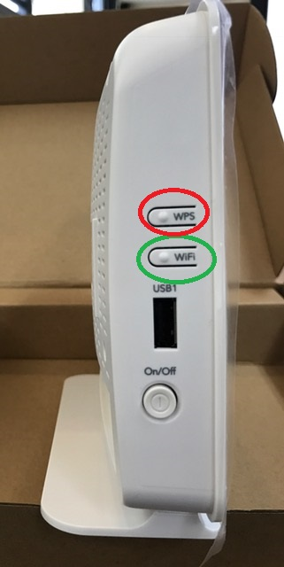

WiFi – This button switches the WiFi capabilities of the Modem on and off. Check the above info for the corresponding status light, you’ll normally want to leave this on at all times. If the WiFi light is off, test this button first to make sure it hasn’t been switched off manually.

WPS – This button switches on WPS authentication which is a temporary method of WiFi connection that removes the security from your network for a set period of time. We generally don’t recommend using this due to the security concerns however some older devices may only support WPS connection.

The Back of the Netcomm Modem

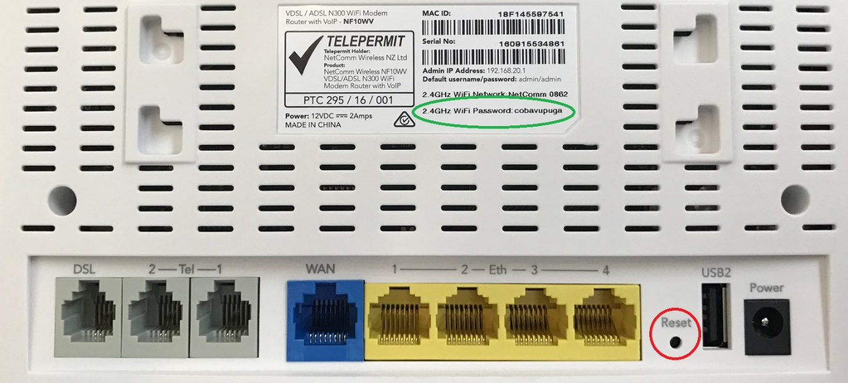

2.4GHz WiFi Password – This is the default WiFi password programmed in to the Modem when you receive it. Please note that this is an example modem, your password will most certainly differ.

Reset – This button is used to reset the Modem to factory default settings. It is strongly advised that you do not press this button without speaking to us first as it guarantees that a full reconfiguration of the Modem will be needed before you can get back online. It will generally be used as a last resort during troubleshooting.